**HOW TO LOGIN TO S4 HANA**

Go to start Enter MSTSC-Remote Desktop Connection

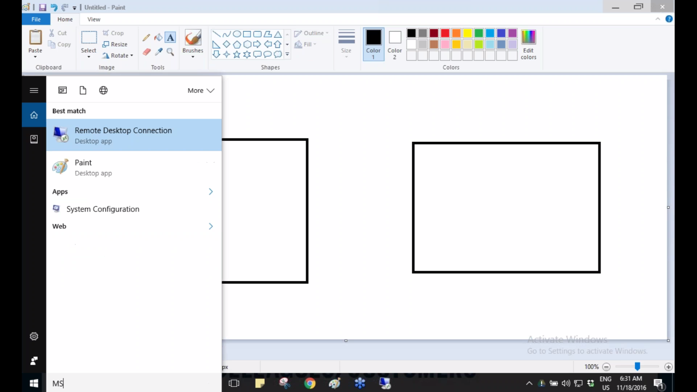CLICK ON REMOTE DESKTOP CONNECTION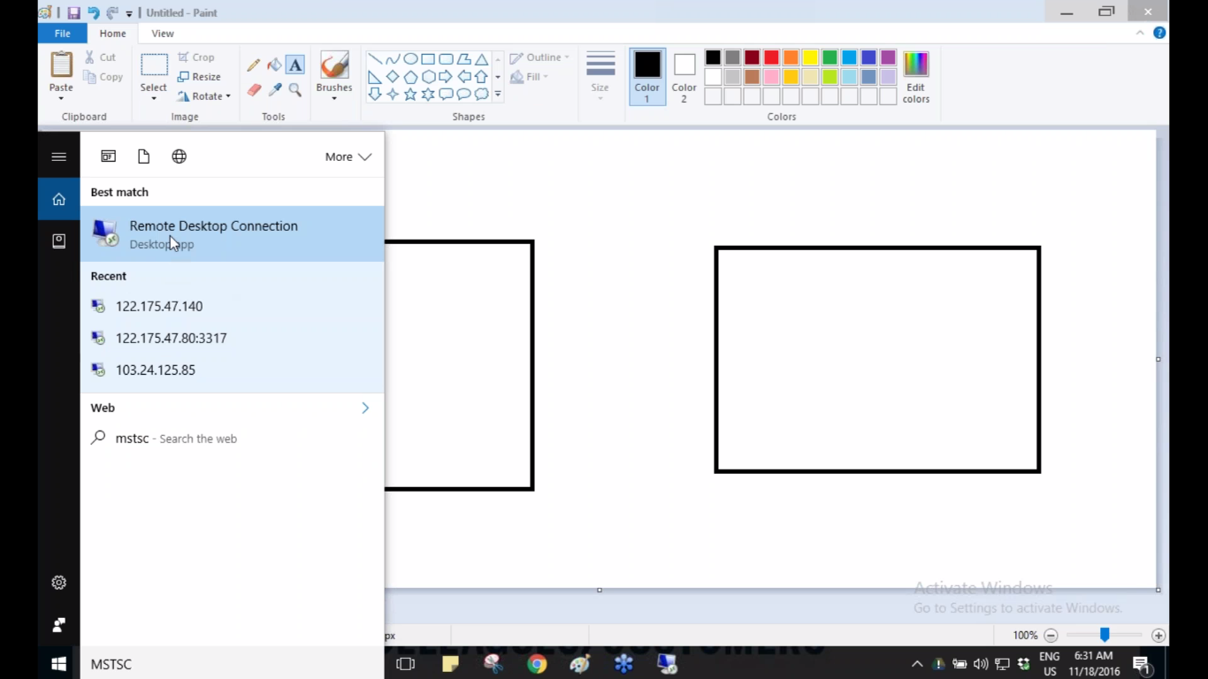 ENTER YOUR IP ADDRESS <-CLICK CONNECT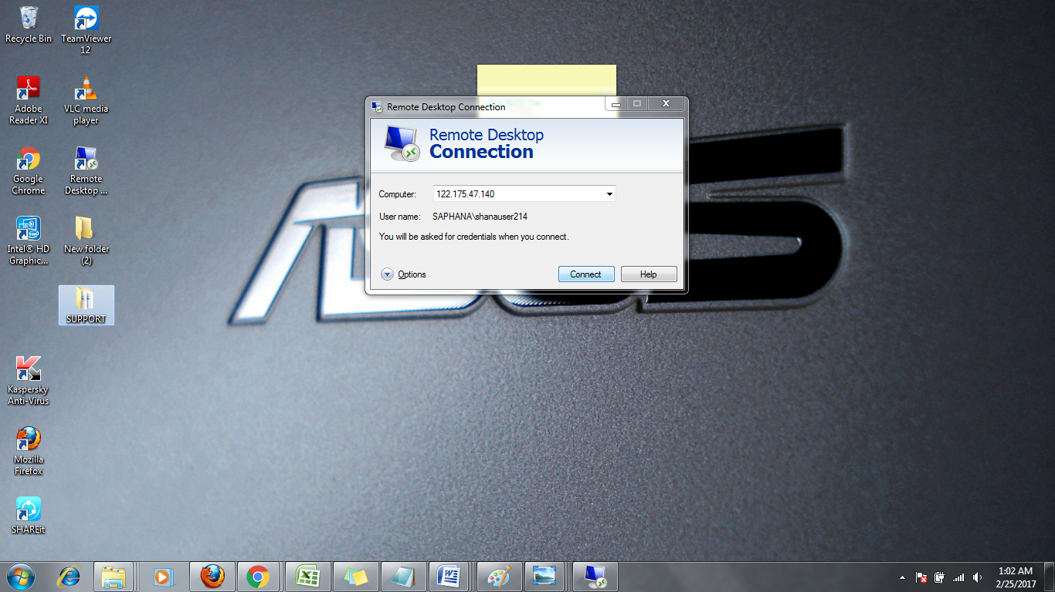

ENTER YOUR S4 CREDENTIALS AND CLICK OK

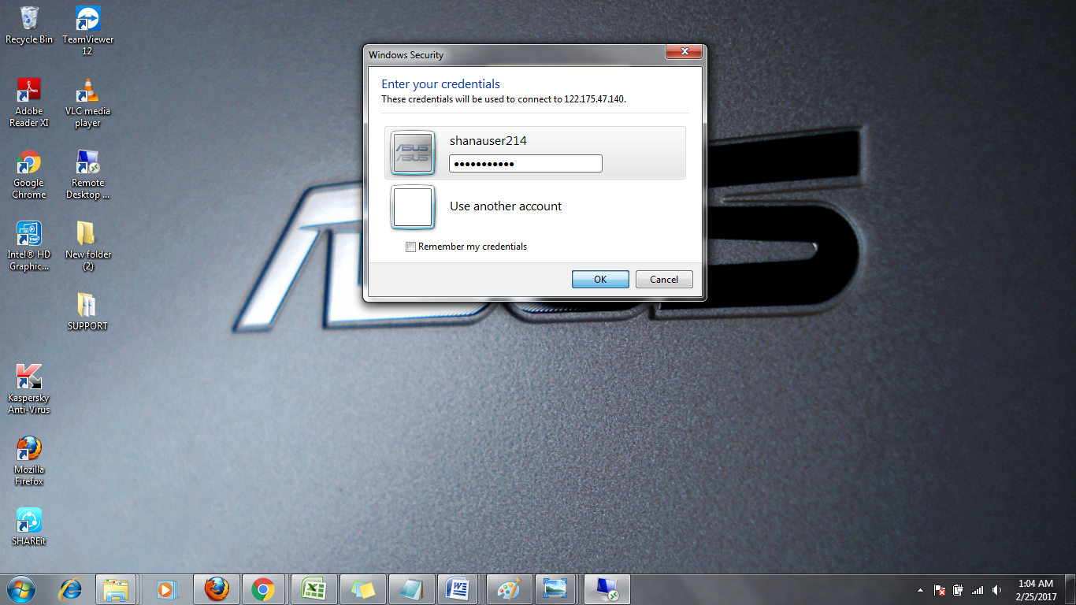

CLICK YES 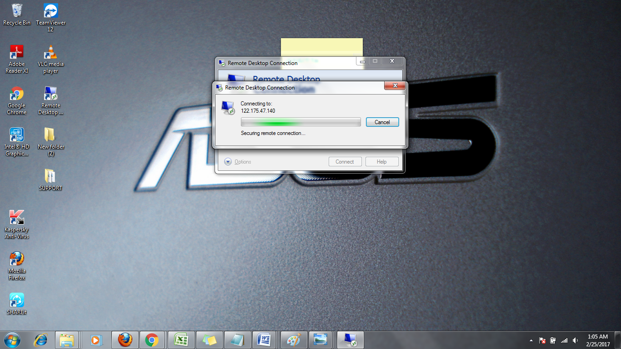 LOGIN SUCCESS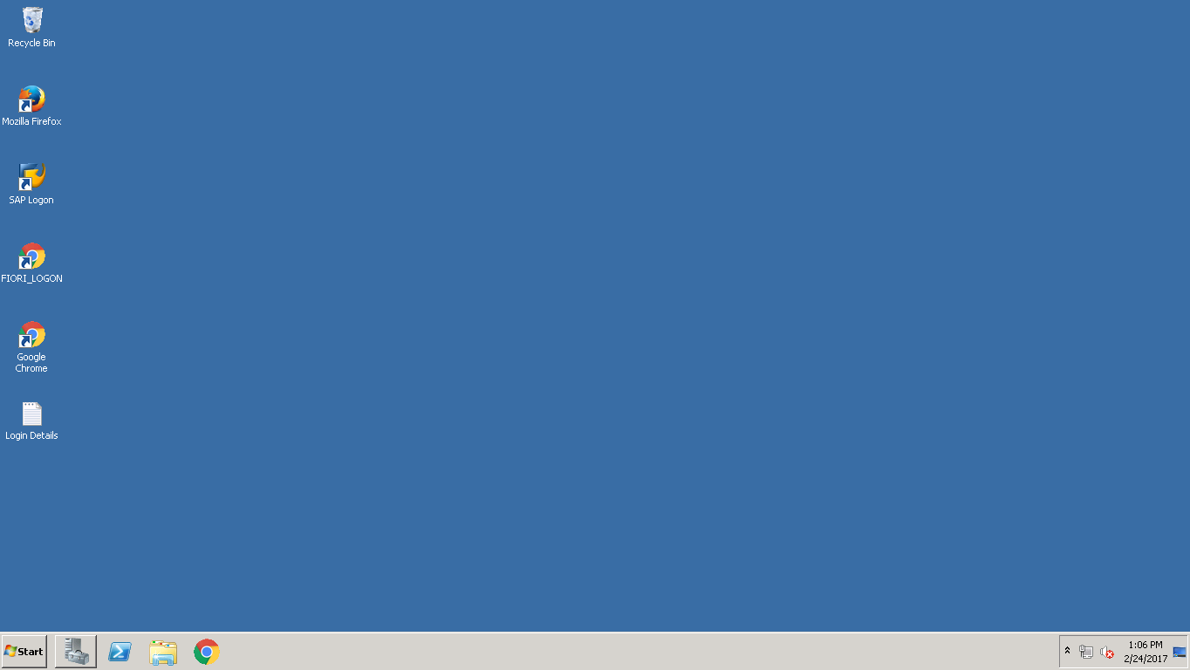GOTO START<-CLICK ALL PROGRAMS<-SELECT SAP LOGON AND CLICK 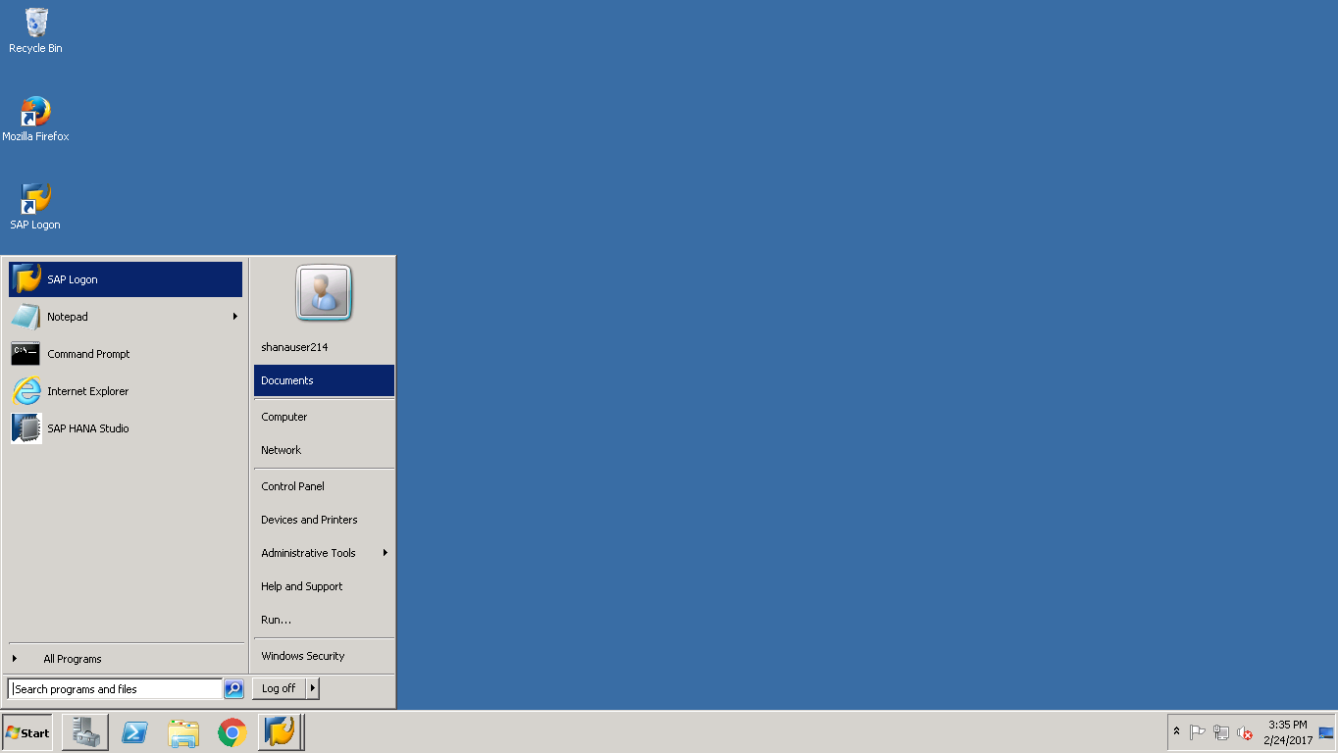 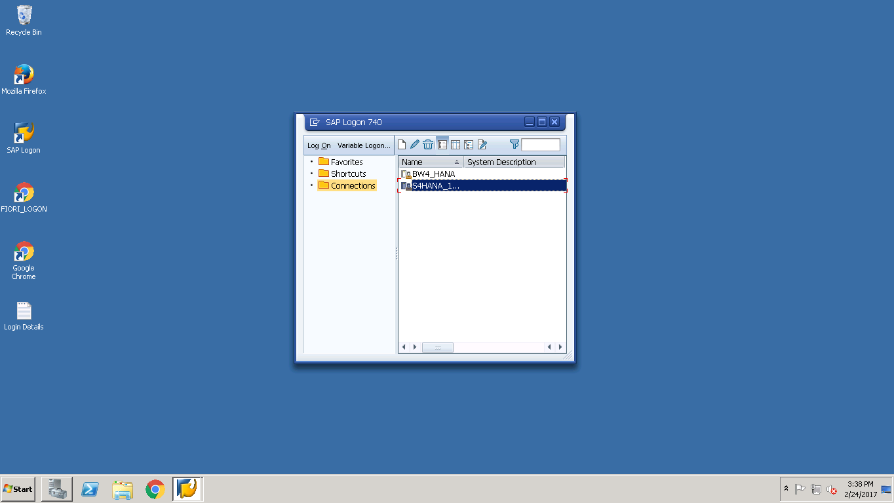 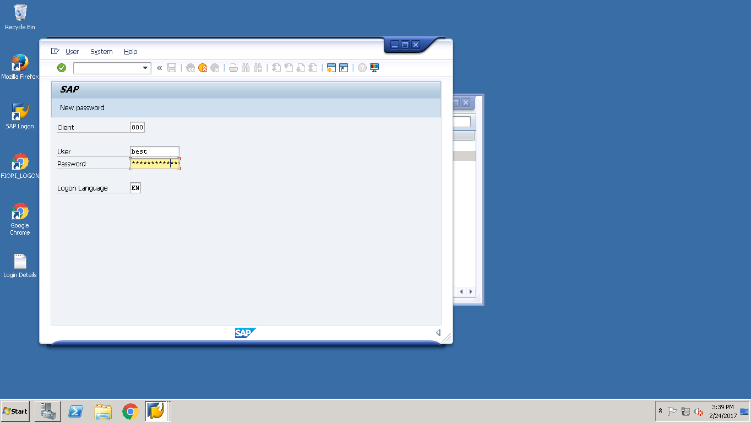 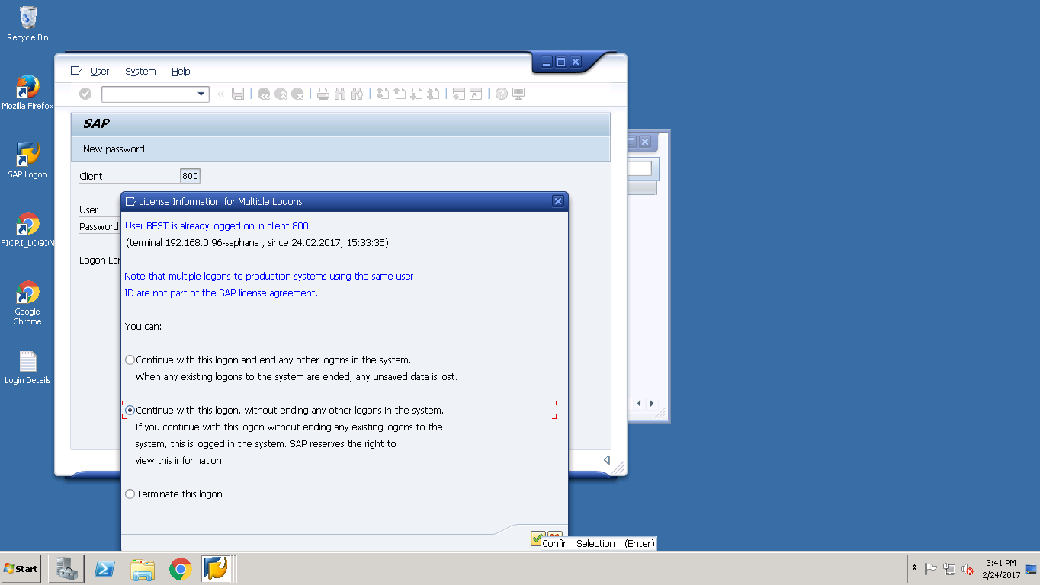

HERE THIS IS S4 HANA LOGIN

